**Module 7 - Spring REST using Spring Boot 3**

|  |
| --- |
| **HandsOn 2**:REST - Country Web Service |

**QUESTION:**

* Write a REST service that returns India country details in the earlier created spring learn application.  
    
  **URL**: /country  
  **Controller**: com.cognizant.spring-learn.controller.CountryController  
  **Method Annotation**: @RequestMapping  
  **Method Name**: getCountryIndia()  
  **Method Implementation**: Load India bean from spring xml configuration and return  
  **Sample Request**: http://localhost:8083/country  
  **Sample Response**:
* {
* "code": "IN",
* "name": "India"
* }
* SME to explain the following aspects:
* What happens in the controller method?
* How the bean is converted into JSON reponse?
* In network tab of developer tools show the HTTP header details received
* In postman click on "Headers" tab to view the HTTP header details received

**Solution:**

**1.Created country.xml Configuration**

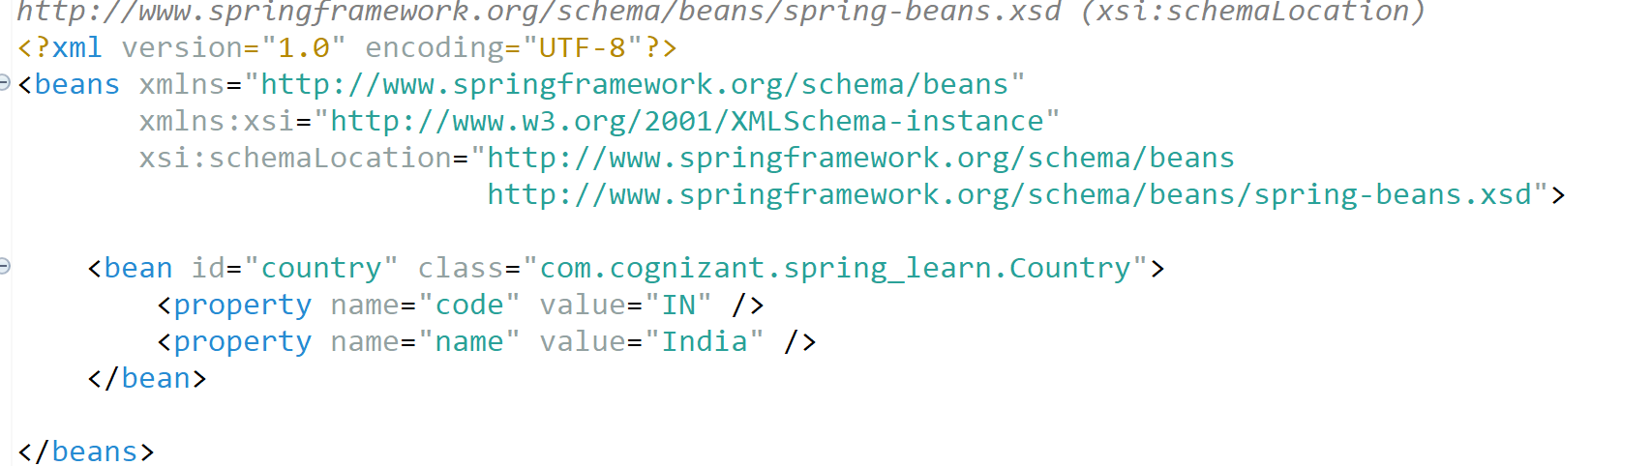

**2. Created Country.java Class**

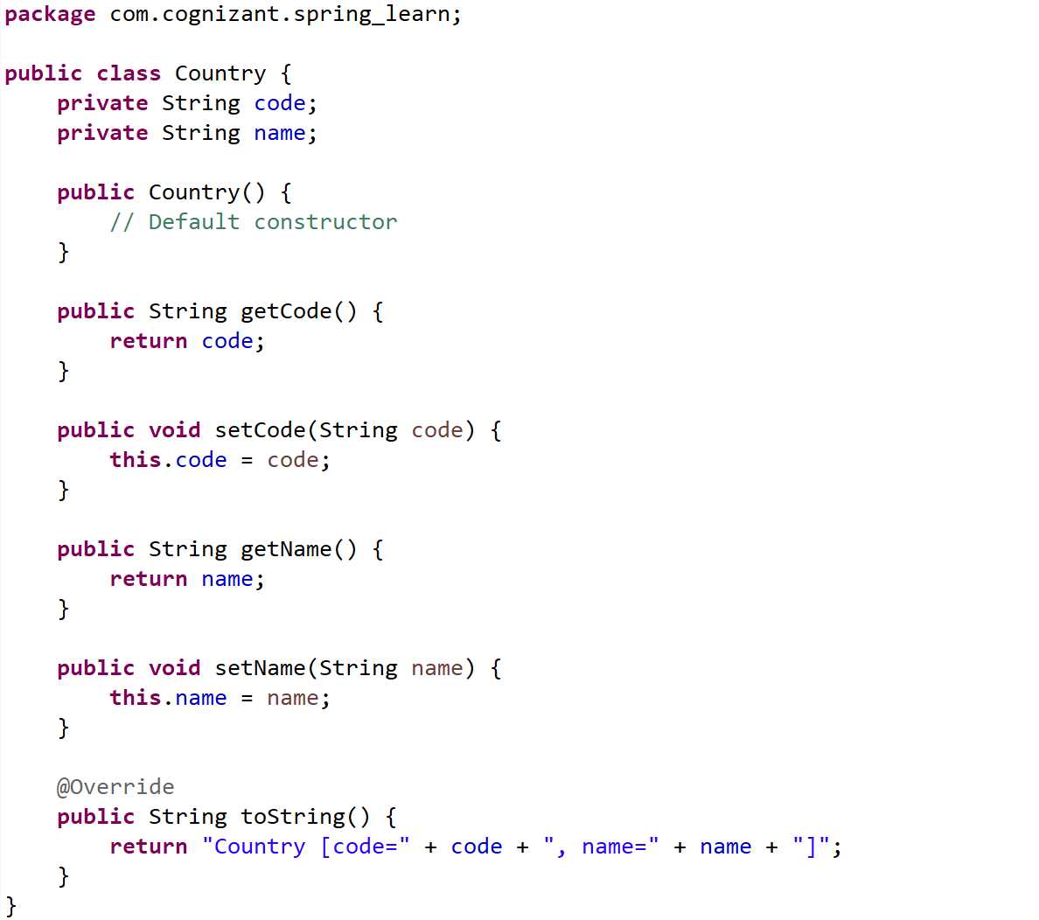 \

**3.Created REST Controller**

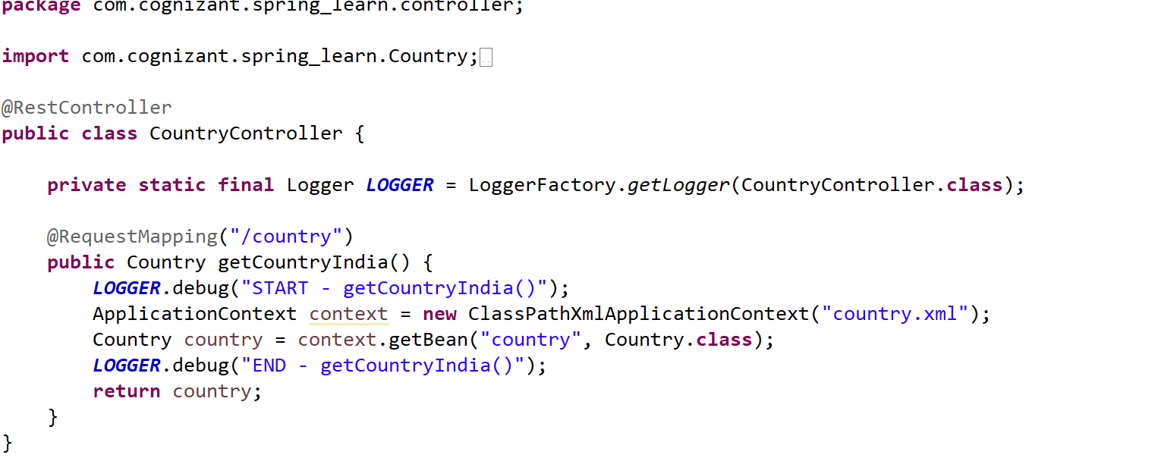

**4.Tested the Endpoint**

